Ex No:1 | EDA-DATA CLEANING
Date:
Aim:
To perform Exploratory Data Analysis (EDA) and data cleaning on the sales dataset using standard data science frameworks (CRISP-DM, SEMMA, and KDD) by handling missing values, removing duplicates, creating derived features, and analyzing data patterns.
Algorithm:
- Import pandas, numpy, and matplotlib.pyplot.
- Load Sales data.xlsx and inspect the dataset structure, missing values, and duplicate records.
- Clean the data by removing duplicate records and dropping the unnecessary Unnamed: 0 column.
- Convert order_date to datetime format and engineer new features such as discounted_price and total_revenue.
- Plot frequency distributions for key variables such as product category, customer region, payment method, and top products, and display a correlation matrix heatmap.
- Summarize the identified sales patterns and business insights, and end execution.

Program:
import pandas as pd
import numpy as np
import matplotlib.pyplot as plt

# CRISP-DM FRAMEWORK
# ============================================================

# 1. BUSINESS UNDERSTANDING
# Objective:
#Analyze sales patterns, product category performance,
#customer regions, payment methods, discounts, and revenue trends.

# 2. DATA UNDERSTANDING

df = pd.read_excel("C:/Users/ramya/Downloads/Sales data.xlsx")

print(df.head())
print(df.shape)
print(df.info())
print(df.describe())
print(df.isnull().sum())
print(df.duplicated().sum())

# 3. DATA PREPARATION

df.drop_duplicates(inplace=True)
df['order_date'] = pd.to_datetime(df['order_date'])
df['discounted_price'] = df['price'] * (1 - df['discount_percent'] / 100)
df['total_revenue'] = df['discounted_price'] * df['quantity_sold']
print(df.head())

# 4. MODELING (EDA)

# Product Category
df['product_category'].value_counts().plot(kind='bar')
plt.title("Product Category")
plt.xlabel("Product Category")
plt.ylabel("Number of Orders")
plt.show()

# Customer Region
df['customer_region'].value_counts().plot(kind='bar')
plt.title("Customer Region")
plt.xlabel("Region")
plt.ylabel("Number of Orders")
plt.show()

# Payment Method
df['payment_method'].value_counts().plot(kind='bar')
plt.title("Payment Method")
plt.xlabel("Payment Method")
plt.ylabel("Number of Orders")
plt.show()

# Top 10 Products
df['product_id'].value_counts().head(10).plot(kind='bar')
plt.title("Top 10 Products")
plt.xlabel("Product ID")
plt.ylabel("Number of Orders")
plt.show()

# Correlation Heatmap
corr = df.select_dtypes(include='number').corr()
plt.figure(figsize=(10, 8))
plt.imshow(corr)
plt.colorbar()
plt.xticks(
range(len(corr.columns)),
corr.columns,
rotation=90
)
plt.yticks(
range(len(corr.columns)),
corr.columns
)
plt.title("Correlation Heatmap")
plt.show()

# 5. EVALUATION
print("Business insights generated successfully.")

# 6. DEPLOYMENT
print("Insights can be deployed through dashboards.")

# SEMMA FRAMEWORK
# ============================================================

# SAMPLE

df = pd.read_excel("C:/Users/ramya/Downloads/Sales data.xlsx")

# EXPLORE

print(df.head())
print(df.info())
print(df.describe())
print(df.isnull().sum())

# MODIFY

df.drop_duplicates(inplace=True)

df.drop(columns='Unnamed: 0', errors='ignore', inplace=True)

df['order_date'] = pd.to_datetime(df['order_date'])

df['discounted_price'] = df['price'] * (1 - df['discount_percent'] / 100)

df['total_revenue'] = df['discounted_price'] * df['quantity_sold']

# MODEL

df['product_category'].value_counts().plot(kind='bar')
plt.show()

df['customer_region'].value_counts().plot(kind='bar')
plt.show()

df['payment_method'].value_counts().plot(kind='bar')
plt.show()
df['product_id'].value_counts().head(10).plot(kind='bar')
plt.show()

corr = df.select_dtypes(include='number').corr()
plt.figure(figsize=(10,8))
plt.imshow(corr)
plt.colorbar()
plt.xticks(
range(len(corr.columns)),
corr.columns,
rotation=90
)
plt.yticks(
range(len(corr.columns)),
corr.columns
)
plt.show()

# ASSESS

print("Sales patterns and trends successfully identified.")

# KDD FRAMEWORK
# ============================================================

# SELECTION

df = pd.read_excel("C:/Users/ramya/Downloads/Sales data.xlsx")

# PREPROCESSING

print(df.info())
print(df.isnull().sum())
print(df.duplicated().sum())
df.drop_duplicates(inplace=True)
df.drop(columns='Unnamed: 0', errors='ignore', inplace=True)

# TRANSFORMATION

df['order_date'] = pd.to_datetime(df['order_date'])
df['discounted_price'] = df['price'] * ( 1 - df['discount_percent'] / 100 )
df['total_revenue'] = ( df['discounted_price'] * df['quantity_sold'] )

# DATA MINING

df['product_category'].value_counts().plot(kind='bar')
plt.title("Product Category")
plt.show()

df['customer_region'].value_counts().plot(kind='bar')
plt.title("Customer Region")
plt.show()

df['payment_method'].value_counts().plot(kind='bar')
plt.title("Payment Method")
plt.show()

df['product_id'].value_counts().head(10).plot(kind='bar')
plt.title("Top 10 Products")
plt.show()

corr = df.select_dtypes(include='number').corr()
plt.figure(figsize=(10,8))
plt.imshow(corr)
plt.colorbar()
plt.xticks(
range(len(corr.columns)),
corr.columns,
rotation=90
)
plt.yticks(
range(len(corr.columns)),
corr.columns
)
plt.title("Correlation Heatmap")
plt.show()

# INTERPRETATION
print("Knowledge discovered from the dataset has been interpreted")
print("to support sales and business decisions.")
Output:
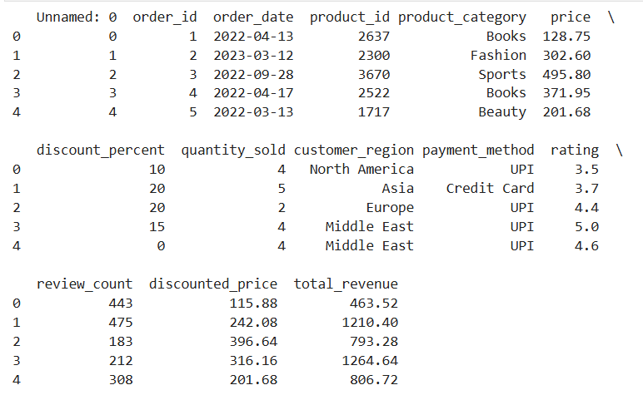
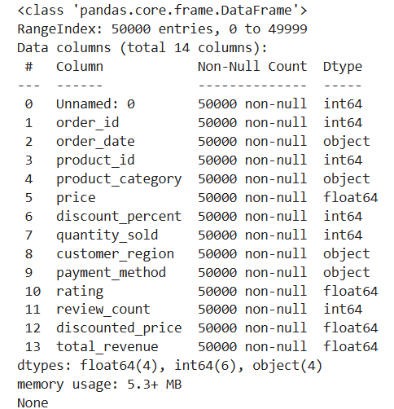

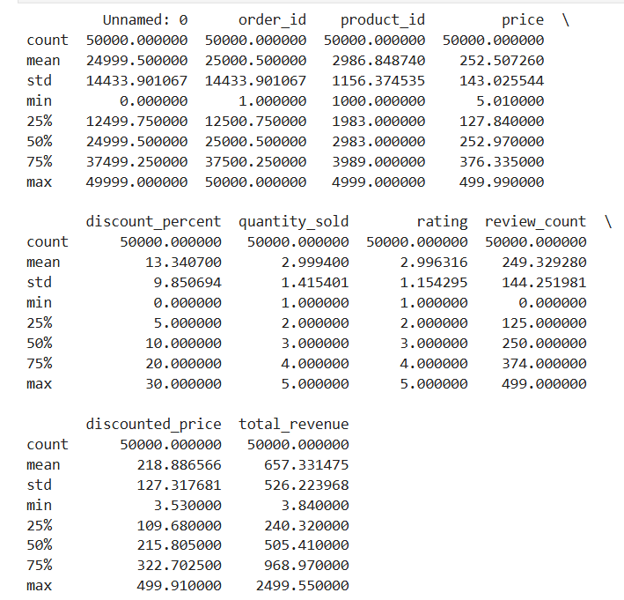

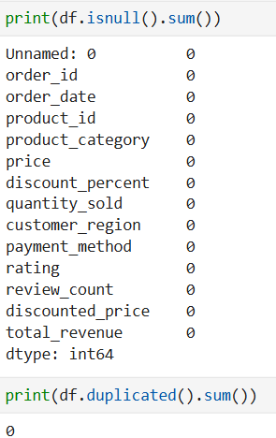
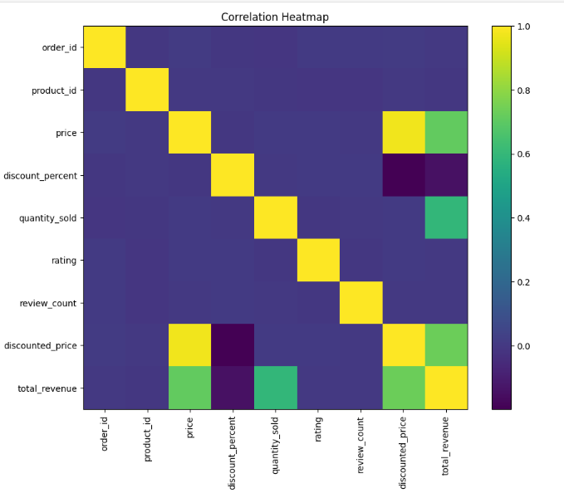

Result:

